Plane and Point

Definition
# Source: AI Source: Provided by: [Data Path: Persons Table -> ID Column: 1, Name_En Column: Motasem Essam] -> From: [ChatGPT] on [7/25/2026]
The relationship between a plane and a point in solid geometry describes the position of a point relative to a plane in three-dimensional space.
A point can occupy one of three positions relative to a plane:
- Point on the plane: The point lies directly on the plane.
- Point above or on one side of the plane: The point does not lie on the plane and is located on one side of it.
- Point below or on the opposite side of the plane: The point does not lie on the plane and is located on the other side.
Mathematically, a plane divides three-dimensional space into two half-spaces. A point either belongs to the plane or lies in one of those half-spaces.
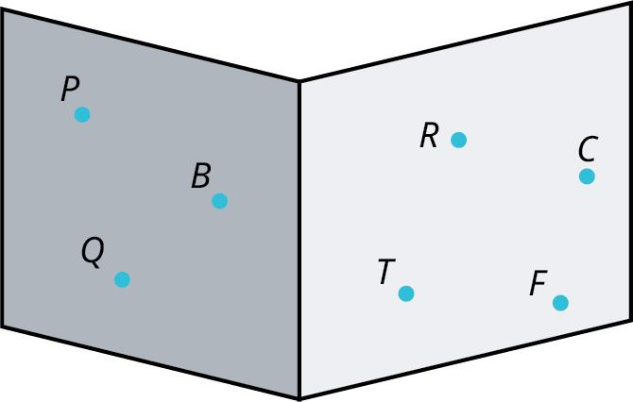
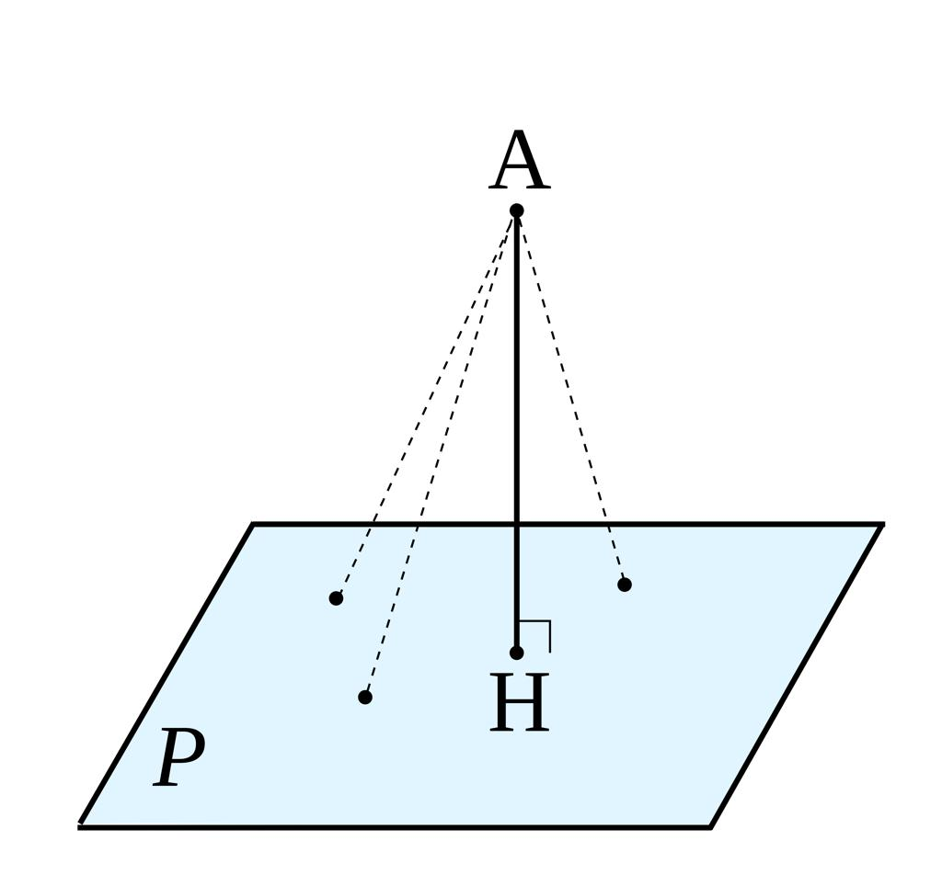
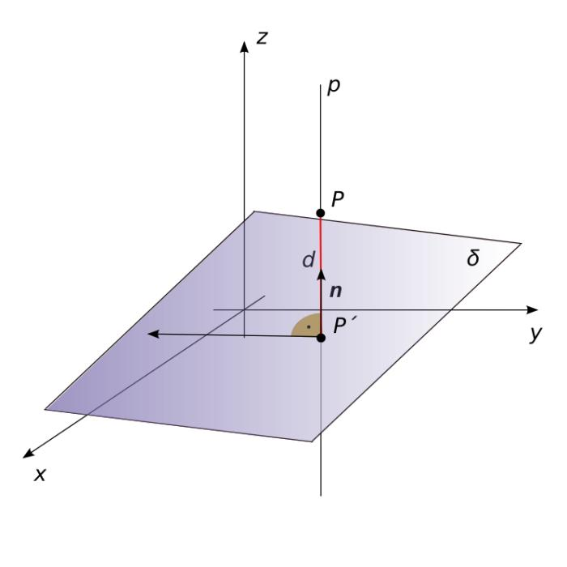

Simple Definition
# Source: AI Source: Provided by: [Data Path: Persons Table -> ID Column: 1, Name_En Column: Motasem Essam] -> From: [ChatGPT] on [7/25/2026]
The relationship between a plane and a point tells us whether the point lies on the plane or is located away from it.
For example:
- A point marked on a tabletop lies on the plane representing the tabletop.
- A point representing a lamp above the tabletop lies on one side of that plane.
- A point representing an object beneath the tabletop lies on the opposite side.
A mathematical plane extends infinitely, so “above” and “below” are relative to the chosen orientation of the plane.

Types of Relationships Between a Plane and a Point
# Source: AI Source: Provided by: [Data Path: Persons Table -> ID Column: 1, Name_En Column: Motasem Essam] -> From: [ChatGPT] on [7/25/2026]
There are two fundamental positional relationships between a point and a plane: the point either lies on the plane or does not lie on it. The second case can be divided into two sides using a chosen orientation.

1. Point on a Plane
# Source: AI Source: Provided by: [Data Path: Persons Table -> ID Column: 1, Name_En Column: Motasem Essam] -> From: [ChatGPT] on [7/25/2026]
The point belongs to the plane. Its perpendicular distance from the plane is zero.
$$P∈α$$
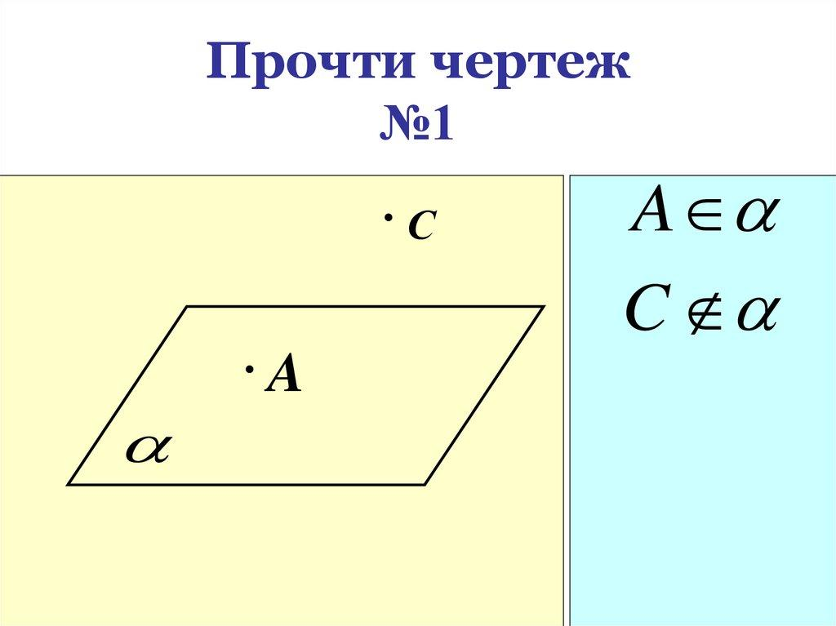

2. Point Outside a Plane
# Source: AI Source: Provided by: [Data Path: Persons Table -> ID Column: 1, Name_En Column: Motasem Essam] -> From: [ChatGPT] on [7/25/2026]
The point does not belong to the plane. Its perpendicular distance from the plane is positive.
$$P∉α$$
A point outside a plane can lie on either side of it. The terms above and below are convenient when the plane is drawn horizontally, but they are not intrinsic geometric properties.
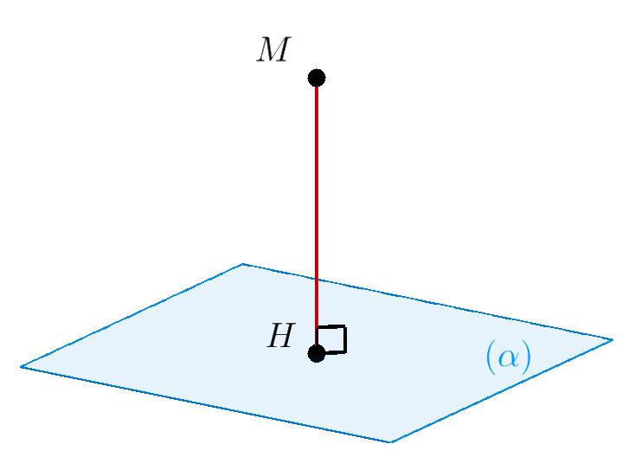

Key Characteristics
# Source: AI Source: Provided by: [Data Path: Persons Table -> ID Column: 1, Name_En Column: Motasem Essam] -> From: [ChatGPT] on [7/25/2026]
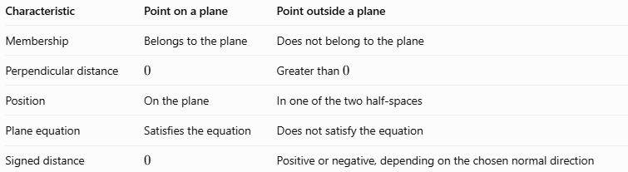
Characteristic | Point on a plane | Point outside a plane
Membership | Belongs to the plane | Does not belong to the plane
Perpendicular distance | $$0$$ | Greater than $0$
Position | On the plane | In one of the two half-spaces
Plane equation | Satisfies the equation | Does not satisfy the equation
Signed distance | $$0$$ | Positive or negative, depending on the chosen normal direction

Mathematical Representation

General equation of a plane
# Source: AI Source: Provided by: [Data Path: Persons Table -> ID Column: 1, Name_En Column: Motasem Essam] -> From: [ChatGPT] on [7/25/2026]
A plane in three-dimensional Cartesian coordinates can be represented by
$$Ax+By+Cz+D=0$$
where $A$, $B$, and $C$ are not all zero.
Let the point be
$$P=\left(x_{0},y_{0},z_{0}\right)$$
To determine the relationship between the point and the plane, substitute its coordinates into the plane equation.
Define
$$S=Ax_{0}+By_{0}+Cz_{0}+D$$
Then:
- If $S=0$, the point lies on the plane.
- If $S≠0$, the point lies outside the plane.
The sign of $S$ indicates which side of the oriented plane contains the point.

Perpendicular distance from a point to a plane
# Source: AI Source: Provided by: [Data Path: Persons Table -> ID Column: 1, Name_En Column: Motasem Essam] -> From: [ChatGPT] on [7/25/2026]
The shortest distance from a point to a plane is measured along a perpendicular line.
For the plane $Ax+By+Cz+D=0$ and point $P=\left(x_{0},y_{0},z_{0}\right)$, the distance is
$$\boxed{d=\frac{\left|Ax_{0}+By_{0}+Cz_{0}+D\right|}{\sqrt{A^{2}+B^{2}+C^{2}}}}$$
The absolute value ensures that distance is never negative.

6.3. Signed distance
# Source: AI Source: Provided by: [Data Path: Persons Table -> ID Column: 1, Name_En Column: Motasem Essam] -> From: [ChatGPT] on [7/25/2026]
The signed distance is
$$\boxed{d_{s}=\frac{Ax_{0}+By_{0}+Cz_{0}+D}{\sqrt{A^{2}+B^{2}+C^{2}}}}$$
A positive or negative result identifies the side relative to the direction of the normal vector $\left(A,B,C\right)$. A result of zero means that the point lies on the plane.

Worked Examples
# Source: AI Source: Provided by: [Data Path: Persons Table -> ID Column: 1, Name_En Column: Motasem Essam] -> From: [ChatGPT] on [7/25/2026]
Example 1: Determine whether a point lies on a plane
Determine the relationship between $P=\left(1,2,3\right)$ and the plane
$$2x+y-z-1=0$$
Step 1: Substitute the coordinates.
$$2\left(1\right)+2-3-1=0$$
Step 2: Evaluate the result.
The equation is satisfied because the result is zero.
Answer: The point $P=\left(1,2,3\right)$ lies on the plane.
Example 2: Determine whether a point is outside a plane
Determine the relationship between $Q=\left(2,1,4\right)$ and the plane
$$x+2y+2z-5=0$$
Substitute the coordinates:
$$2+2\left(1\right)+2\left(4\right)-5=7$$
Since $7≠0$, the point does not lie on the plane.
Its perpendicular distance from the plane is
$$d=\frac{\left|7\right|}{\sqrt{1^{2}+2^{2}+2^{2}}}$$
$$d=\frac{7}{\sqrt{9}}=\boxed{\frac{7}{3}}$$
Answer: The point lies outside the plane, at a perpendicular distance of $\frac{7}{3}$ units.
Example 3: Determine which side of a plane contains a point
Consider the plane
$$z=3$$
and the points
$$A=\left(1,2,5\right), B=\left(1,2,1\right)$$
For point $A$,
$$5-3=2>0$$
For point $B$,
$$1-3=-2<0$$
Therefore, $A$ lies on the $z>3$ side, while $B$ lies on the $z<3$ side.
Both points are outside the plane, and each is $2$ units away from it.

Comparison with Related Concepts
# Source: AI Source: Provided by: [Data Path: Persons Table -> ID Column: 1, Name_En Column: Motasem Essam] -> From: [ChatGPT] on [7/25/2026]
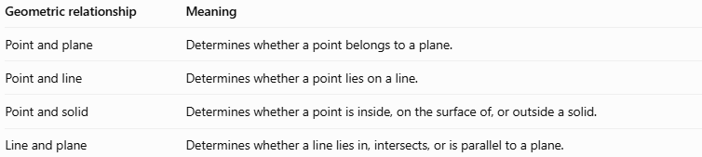
Geometric relationship | Meaning
Point and plane | Determines whether a point belongs to a plane.
Point and line | Determines whether a point lies on a line.
Point and solid | Determines whether a point is inside, on the surface of, or outside a solid.
Line and plane | Determines whether a line lies in, intersects, or is parallel to a plane.

Applications
# Source: AI Source: Provided by: [Data Path: Persons Table -> ID Column: 1, Name_En Column: Motasem Essam] -> From: [ChatGPT] on [7/25/2026]
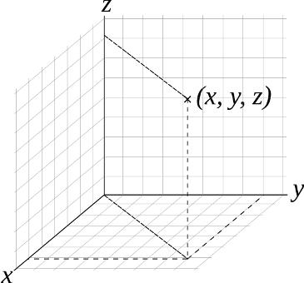
Computer graphics
Determine whether a 3D point lies on a surface or on either side of a clipping plane.
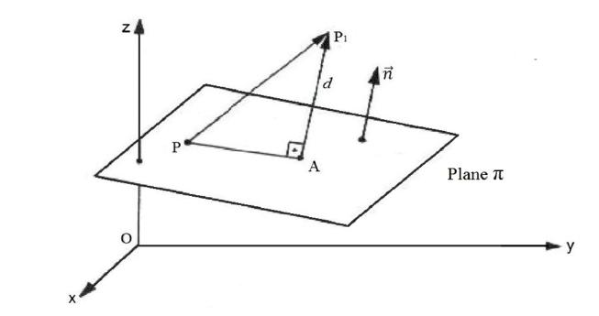
Engineering and CAD
Calculate the perpendicular distance between a reference surface and a specified point.
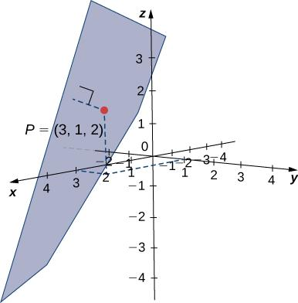
Coordinate geometry
Test whether coordinates satisfy a plane equation and classify points relative to that plane.

Key Points
# Source: AI Source: Provided by: [Data Path: Persons Table -> ID Column: 1, Name_En Column: Motasem Essam] -> From: [ChatGPT] on [7/25/2026]
- A point either lies on a plane or lies outside it.
- Substitution into the plane equation determines membership.
- A zero result means the point lies on the plane.
- A nonzero result means the point lies outside the plane.
- The perpendicular distance is the shortest distance from the point to the plane.
- The sign of the signed distance identifies the side relative to the chosen normal direction.

Conclusion
# Source: AI Source: Provided by: [Data Path: Persons Table -> ID Column: 1, Name_En Column: Motasem Essam] -> From: [ChatGPT] on [7/25/2026]
The relationship between a plane and a point is a fundamental concept in solid geometry. Using the equation of a plane, we can determine whether a point lies on the plane, identify which side contains it, and calculate its perpendicular distance from the plane.

